Exploring Music: Part 1

Lyrical Analysis

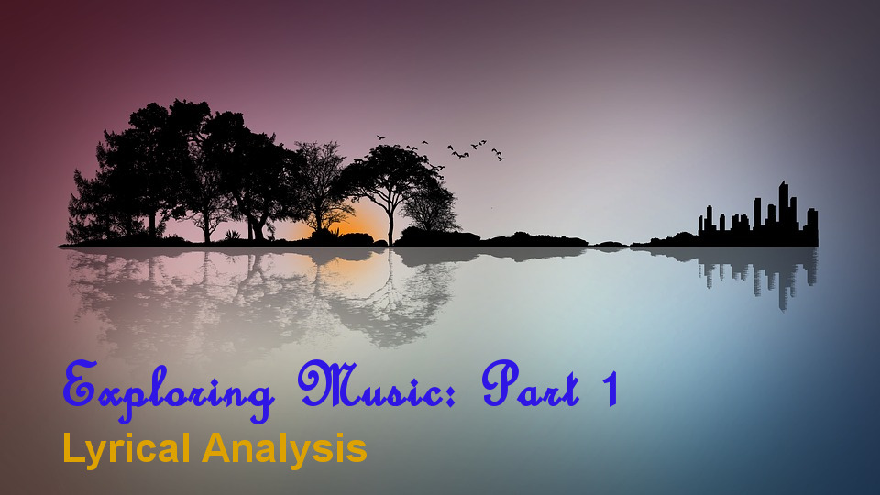

**References:**

Prince analysis

<https://www.datacamp.com/community/tutorials/R-nlp-machine-learning>

<https://www.datacamp.com/community/tutorials/sentiment-analysis-R>

The Ramones

<http://r-blog.salvaggio.net/?p=521>

Misc

<http://tamaszilagyi.com/blog/a-tidy-text-analysis-of-rick-and-morty/>

<https://github.com/walkerkq/musiclyrics>

Radiohead & Spotify API

<http://www.rcharlie.com/post/fitter-happier/>

<https://github.com/charlie86/spotifyr>

<https://developer.spotify.com/web-api/object-model/#audio-features-object>

<http://rcharlie.net/sentify/>

The “gloom” index

<http://blog.revolutionanalytics.com/2017/02/finding-radioheads-most-depressing-song-with-r.html>

<http://www.everydayanalytics.ca/2013/06/radiohead-lyrics-data-visualization-and-content-analysis.html>

**Purpose of this analysis**

1. For the fun of it, the learning, and the practice

**Questions and problem statement**

See ideas board section at end of this document for more ideas

Is it possible to identify themes that appeal to society based on how well a song is received?

Is it possible to predict whether a song will do well based on lyrical analysis alone?

What does this lyrical analysis dataset look like?

How many songs have we got, how many artists?

How are the lyrics structured – is there a difference of patterns by Band? Can we see the creativity differences?

What cleaning and prep do we need to apply to the dataset?

* Capitalisation of places and names of people
* Convert numeric numbers to word numbers?

What are the word frequencies (with and without stop words)

What is the **lyrical** density? What is the **lexical** density?

How close to the phi ratio and or Fibonacci sequence is a piece of music? How will we measure this, what method?

Can we identify **syllables** in the music lyrics and **rhyming words**? Rationale: Music lyrics are designed differently to a poem, or a sentence or a regular written communication, therefore should be treated as such. Music lyrics have a specific syllable and rhyming nature to them, they are designed to flow with an audio overlay

Can we cross reference songs to the “million song dataset” (warning: HD5 format, need a package to convert to usable R formats)

**Future analysis:**

**Reading the musical score/audio file** can we feed these through a DSP and perform a clustering (unsupervised learning) explorative analysis across all the songs in the analysis

Guitar solos from the album (how would you even analyse this? How different/similar are they? How do you measure it?)

* Led Zeppelin – Kashmir
* U2 – Bullet the Blue Sky

Can we detect what type of musical instruments are present in a piece of music? Ie: Singer, percussion, guitar, brass, strings, piano, harmonica

Dragonforce – Through the Fire and the Flames

The challenges a human has in articulating emotions using logic or words

Perhaps a machine learning algorithm can help us make sense of music

Copyright for lyrics belongs to the artists

Process:

1. Preparation of lyrics (download, save as doc/pdf)
2. Read in PDF
3. Data cleaning. Cleanup lyric sheets

Prep data, clean and remove uninformative words

Explore data

Check token words, what is the lyrical complexity?

Unsupervised learning

|  |  |  |  |  |  |  |
| --- | --- | --- | --- | --- | --- | --- |
| **Artist** | **Album** | **Release Date** | **Genre** | **Tracks** | **Review tags** | **Other Notes** |
| Daft Punk | Discovery | February 26, 2001 | Electronic | 1. One More Time 2. Aerodynamic 3. Digital Love 4. Harder, Better, Faster, Stronger 5. Crescendolls 6. Nightvision 7. Superheroes 8. High Life 9. Something About Us 10. Voyager 11. Veridis Quo 12. Short Circuit 13. Face To Face 14. Too Long | Electronic, house, rock, techno, funk, modern disco | Aerodynamic, Crescendolls, Nightvision, Superheroes, High Life, Voyager, Veridis Quo and Short Circuit are instrumental songs. We will include these for sound analysis in a subsequent exploration of music analysis.  Music video movie “Interstella 555: The Story of the Secret Star System”. The film is the visual realization of Discovery.  <http://www.imdb.com/title/tt0368667/> |
| U2 | The Joshua Tree | March 9, 1987 | Rock | 1. ["Where the Streets Have No Name"](https://genius.com/U2-where-the-streets-have-no-name-lyrics) 2. ["I Still Haven't Found What I'm Looking For"](https://genius.com/U2-i-still-havent-found-what-im-looking-for-lyrics) 3. ["With or Without You"](https://genius.com/U2-with-or-without-you-lyrics) 4. ["Bullet the Blue Sky"](https://genius.com/U2-bullet-the-blue-sky-lyrics) 5. ["Running To Stand Still"](https://genius.com/U2-running-to-stand-still-lyrics) 6. ["Red Hill Mining Town"](https://genius.com/U2-red-hill-mining-town-lyrics) 7. ["In God's Country"](https://genius.com/U2-in-gods-country-lyrics) 8. ["Trip Through The Wires"](https://genius.com/U2-trip-through-your-wires-lyrics) 9. ["One Tree Hill"](https://genius.com/U2-one-tree-hill-lyrics) 10. ["Exit"](https://genius.com/U2-exit-lyrics) 11. ["Mothers of the Disappeared"](https://genius.com/U2-mothers-of-the-disappeared-lyrics) | Rock, gospel | One of the biggest selling albums of all time. 30th Anniversary of it’s release in 2017 saw U2 take it on tour. |
| Elton John | Honky Chateau | May 19, 1972 | Rock | |  |  | | --- | --- | | 01 | [Honky Cat lyrics](https://www.letssingit.com/elton-john-lyrics-honky-cat-dw948sb) |  |  |  | | --- | --- | | 02 | [Mellow lyrics](https://www.letssingit.com/elton-john-lyrics-mellow-92xdz63) |  |  |  | | --- | --- | | 03 | [I Think I'm Going To Kill Myself lyrics](https://www.letssingit.com/elton-john-lyrics-i-think-i-m-going-to-kill-myself-2zchrhk) |  |  |  | | --- | --- | | 04 | [Susie (Dramas) lyrics](https://www.letssingit.com/elton-john-lyrics-susie-dramas-5f8n82n) |  |  |  | | --- | --- | | 05 | [Rocket Man (I Think It's Going To Be A Long, Long Time) lyrics](https://www.letssingit.com/elton-john-lyrics-rocket-man-i-think-it-s-going-to-be-a-long-long-time-7s71cxx) |  |  |  | | --- | --- | | 06 | [Salvation lyrics](https://www.letssingit.com/elton-john-lyrics-salvation-29b1wfp) |  |  |  | | --- | --- | | 07 | [Slave lyrics](https://www.letssingit.com/elton-john-lyrics-slave-1261t6f) |  |  |  | | --- | --- | | 08 | [Amy lyrics](https://www.letssingit.com/elton-john-lyrics-amy-n7kblrc) |  |  |  | | --- | --- | | 09 | [Mona Lisa And Mad Hatters lyrics](https://www.letssingit.com/elton-john-lyrics-mona-lisa-and-mad-hatters-kwmqbvw) |  |  |  | | --- | --- | | 10 | [Hercules lyrics](https://www.letssingit.com/elton-john-lyrics-hercules-t181lw1) | | Rock, pop, rock & roll | Rolling Stone believes this was the album which marked the transformation of Elton John from gentle singer/songwriter to a legitimate rock star  <https://www.rollingstone.com/music/pictures/readers-poll-the-10-best-elton-john-albums-20130918/5-honky-chateau-3-78-9> |
| Killswitch Engage | Alive or Just Breathing | 2002 | metalcore | [1. Numbered Days](http://www.darklyrics.com/lyrics/killswitchengage/aliveorjustbreathing.html#1) [2. Self Revolution](http://www.darklyrics.com/lyrics/killswitchengage/aliveorjustbreathing.html#2) [3. Fixation On The Darkness](http://www.darklyrics.com/lyrics/killswitchengage/aliveorjustbreathing.html#3) [4. My Last Serenade](http://www.darklyrics.com/lyrics/killswitchengage/aliveorjustbreathing.html#4) [5. Life To Lifeless](http://www.darklyrics.com/lyrics/killswitchengage/aliveorjustbreathing.html#5) [6. Just Barely Breathing](http://www.darklyrics.com/lyrics/killswitchengage/aliveorjustbreathing.html#6) [7. To The Sons Of Man](http://www.darklyrics.com/lyrics/killswitchengage/aliveorjustbreathing.html#7) [8. Temple From The Within](http://www.darklyrics.com/lyrics/killswitchengage/aliveorjustbreathing.html#8) [9. The Element Of One](http://www.darklyrics.com/lyrics/killswitchengage/aliveorjustbreathing.html#9) [10. Vide Infra](http://www.darklyrics.com/lyrics/killswitchengage/aliveorjustbreathing.html#10) [11. Without A Name](http://www.darklyrics.com/lyrics/killswitchengage/aliveorjustbreathing.html#11) [12. Rise Inside](http://www.darklyrics.com/lyrics/killswitchengage/aliveorjustbreathing.html#12) [13. When The Balance Is Broken](http://www.darklyrics.com/lyrics/killswitchengage/aliveorjustbreathing.html#13) | Hardcore metal | Loudwire (<http://loudwire.com/killswitch-engage-albums-ranked/>) suggests this is the greatest album KsE produced. |
| Iron Maiden | Powerslave | 1984 | Heavy metal | [1. Aces High](http://www.darklyrics.com/lyrics/ironmaiden/powerslave.html#1) [2. 2 Minutes To Midnight](http://www.darklyrics.com/lyrics/ironmaiden/powerslave.html#2) [3. Losfer Words (Big 'Orra)](http://www.darklyrics.com/lyrics/ironmaiden/powerslave.html#3) [4. Flash Of The Blade](http://www.darklyrics.com/lyrics/ironmaiden/powerslave.html#4) [5. The Duellists](http://www.darklyrics.com/lyrics/ironmaiden/powerslave.html#5) [6. Back In The Village](http://www.darklyrics.com/lyrics/ironmaiden/powerslave.html#6) [7. Powerslave](http://www.darklyrics.com/lyrics/ironmaiden/powerslave.html#7) [8. Rime Of The Ancient Mariner](http://www.darklyrics.com/lyrics/ironmaiden/powerslave.html#8) | Hard rock, heavy metal | The greatest album Iron Maiden produced.  <https://www.loudersound.com/features/every-iron-maiden-album-ranked-from-worst-to-best>  Adrian Smith - Lead and Rhythm Guitars Bruce Dickinson - Vocals Dave Murray - Lead and Rhythm Guitars Nicko McBrain - Drums Steve Harris - Bass |
| Led Zeppelin | Physical Graffiti | 1975 | Rock | 01. [Custard Pie](http://www.metalstorm.net/bands/lyrics.php?album_id=4822#60745) 02. [The Rover](http://www.metalstorm.net/bands/lyrics.php?album_id=4822#60746) 03. [In My Time Of Dying](http://www.metalstorm.net/bands/lyrics.php?album_id=4822#60747) 04. [Houses Of The Holy](http://www.metalstorm.net/bands/lyrics.php?album_id=4822#60748) 05. [Trampled Under Foot](http://www.metalstorm.net/bands/lyrics.php?album_id=4822#60749) 06. [Kashmir](http://www.metalstorm.net/bands/lyrics.php?album_id=4822#60750) 07. [In The Light](http://www.metalstorm.net/bands/lyrics.php?album_id=4822#60751) 08. [Bron-Yr-Aur](http://www.metalstorm.net/bands/lyrics.php?album_id=4822#60752) 09. [Down By The Seaside](http://www.metalstorm.net/bands/lyrics.php?album_id=4822#60753) 10. [Ten Years Gone](http://www.metalstorm.net/bands/lyrics.php?album_id=4822#60754) 11. [Night Flight](http://www.metalstorm.net/bands/lyrics.php?album_id=4822#60755) 12. [The Wanton Song](http://www.metalstorm.net/bands/lyrics.php?album_id=4822#60756) 13. [Boogie With Stu](http://www.metalstorm.net/bands/lyrics.php?album_id=4822#60757) 14. [Black Country Woman](http://www.metalstorm.net/bands/lyrics.php?album_id=4822#60758) 15. [Sick Again](http://www.metalstorm.net/bands/lyrics.php?album_id=4822#60759) | Classic rock, Rock, Classic metal | Kashmir is one of Bree’s fave songs!  Bron-Yr-Aur is an instrumental |

## Method of development

1. Decide on the plan
2. Acquire song lyrics and access to audio files (spotify)
3. Lyrics > webscrape, convert to docx > PDF
4. Apply some useful data flags

## Ideas board

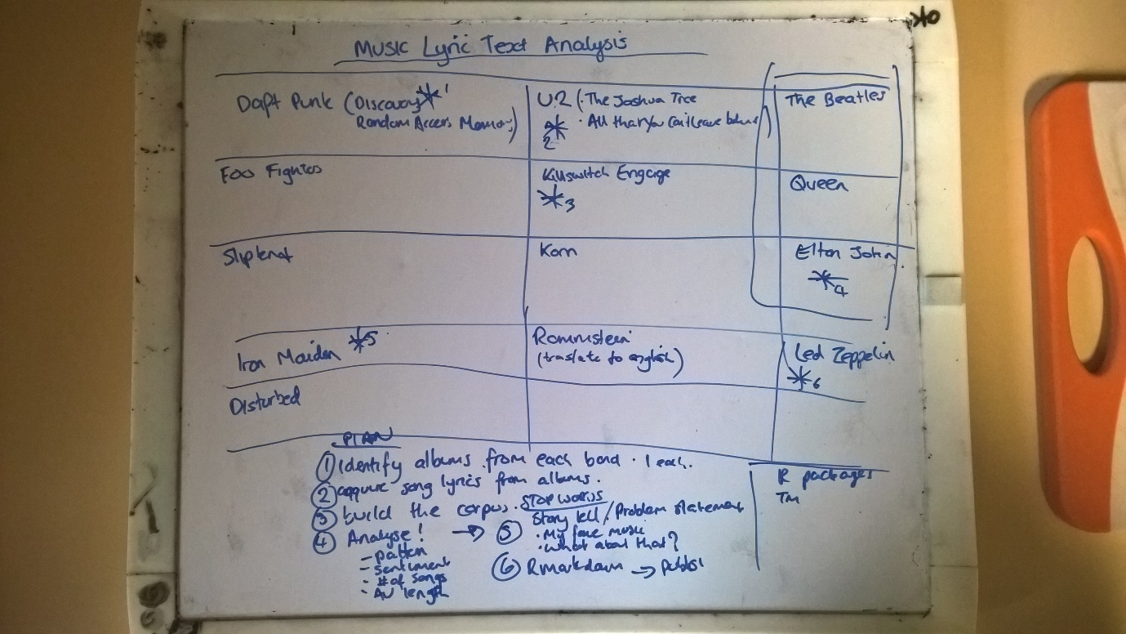

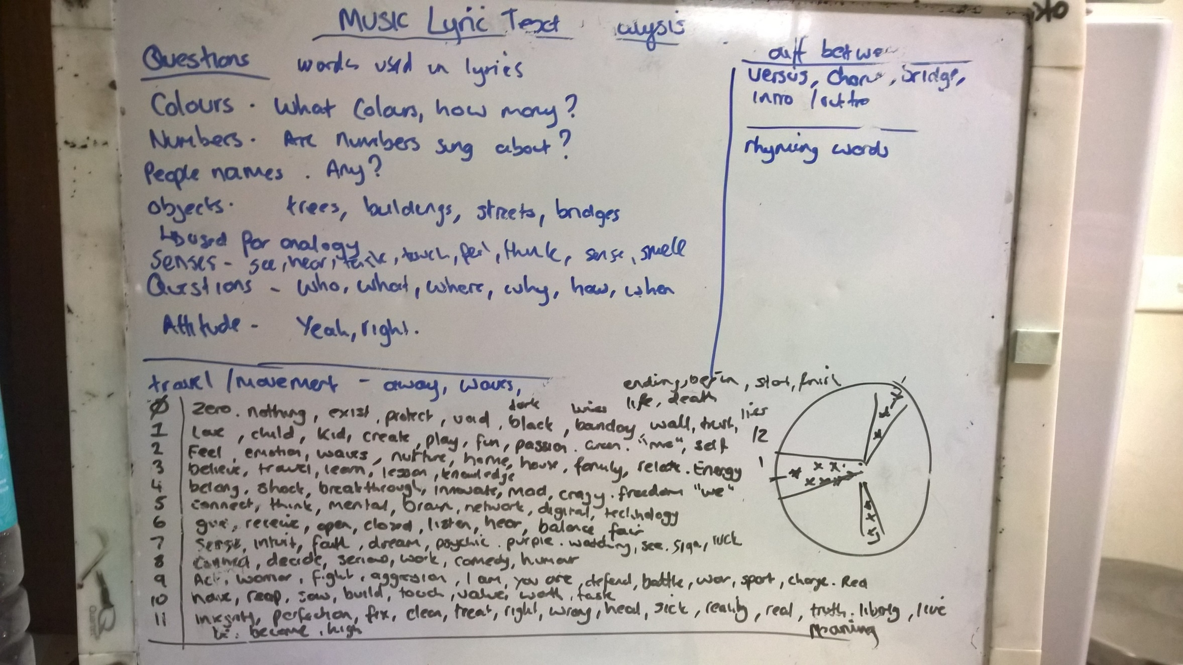

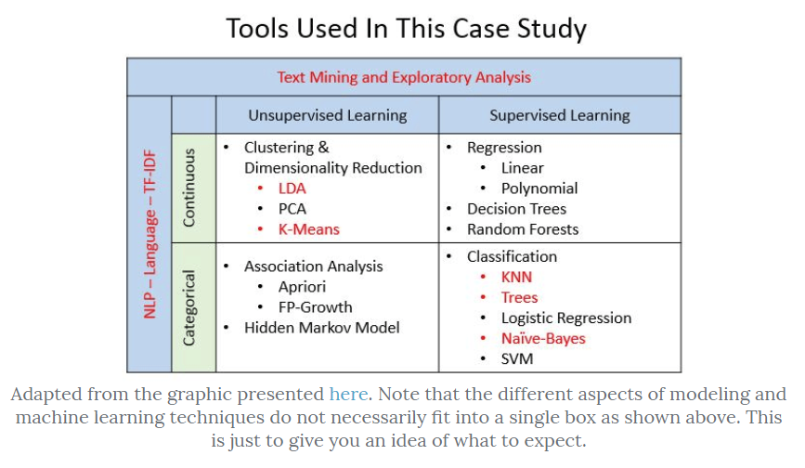

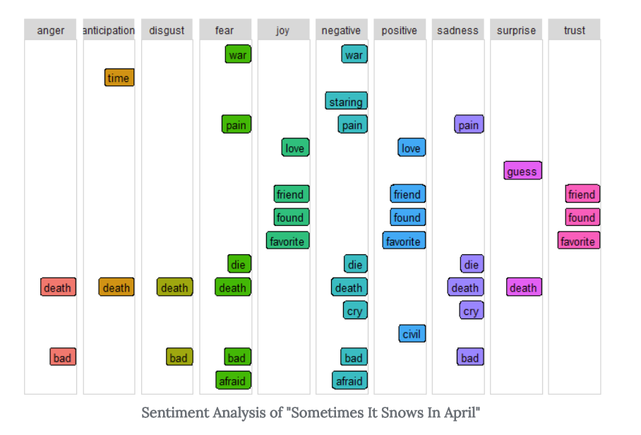

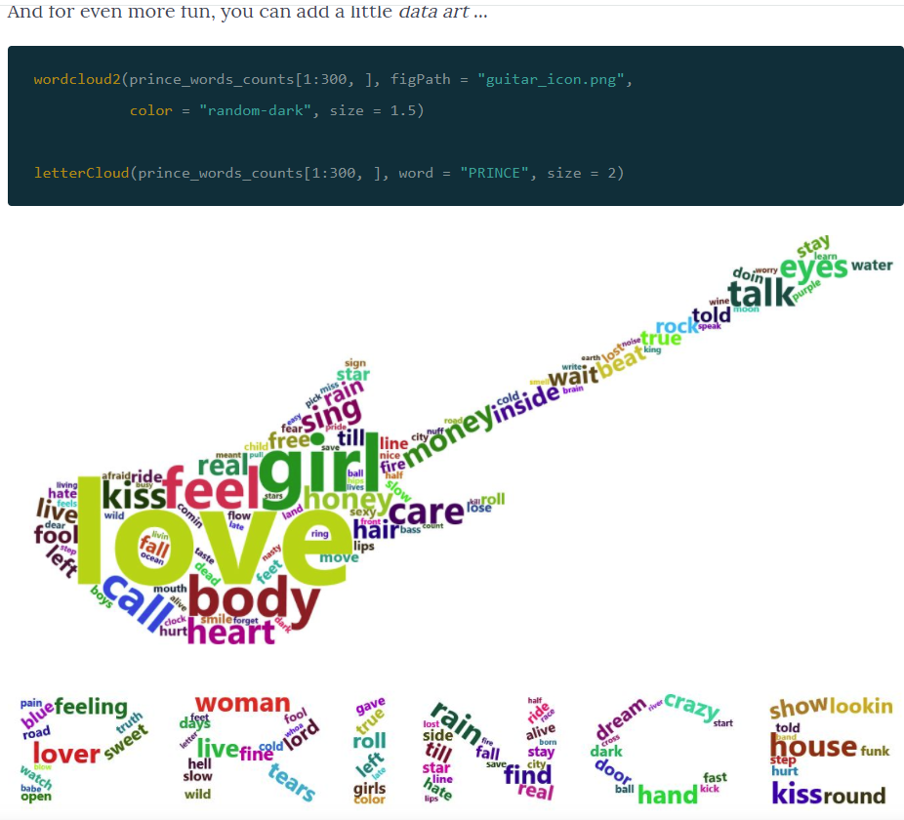

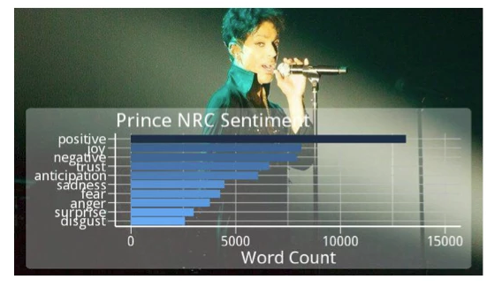

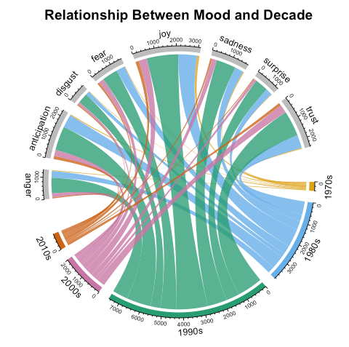

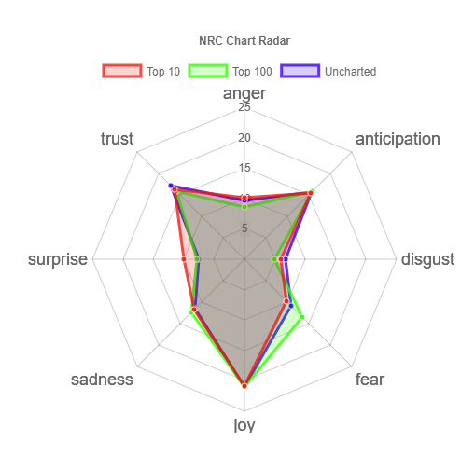

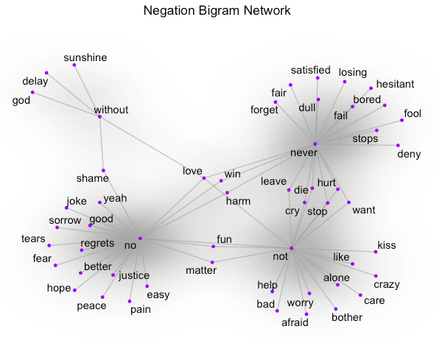

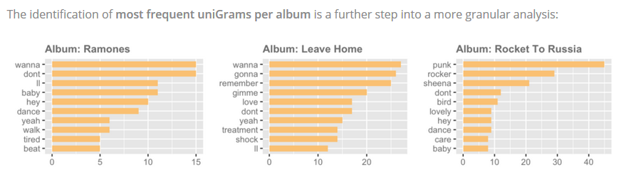

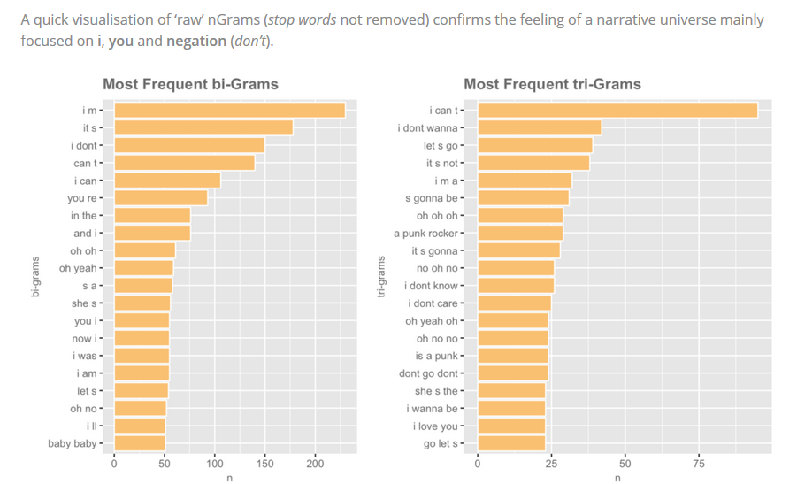

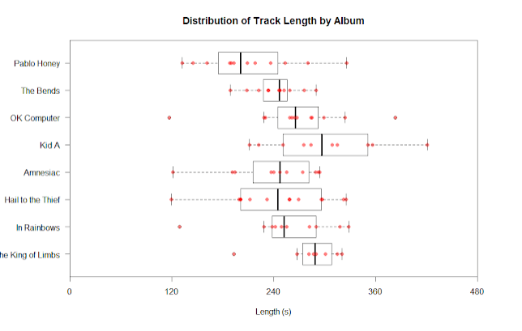

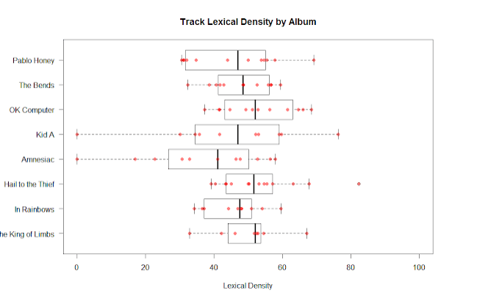

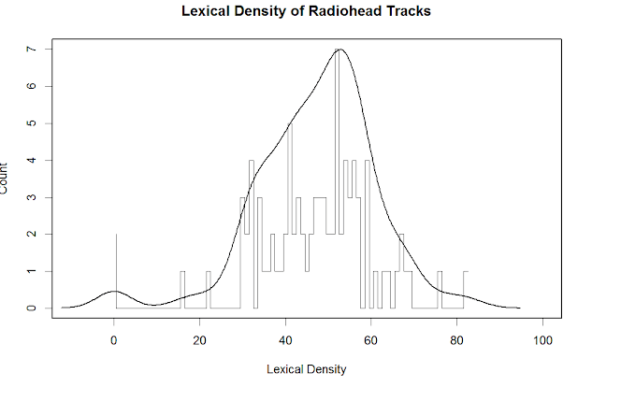

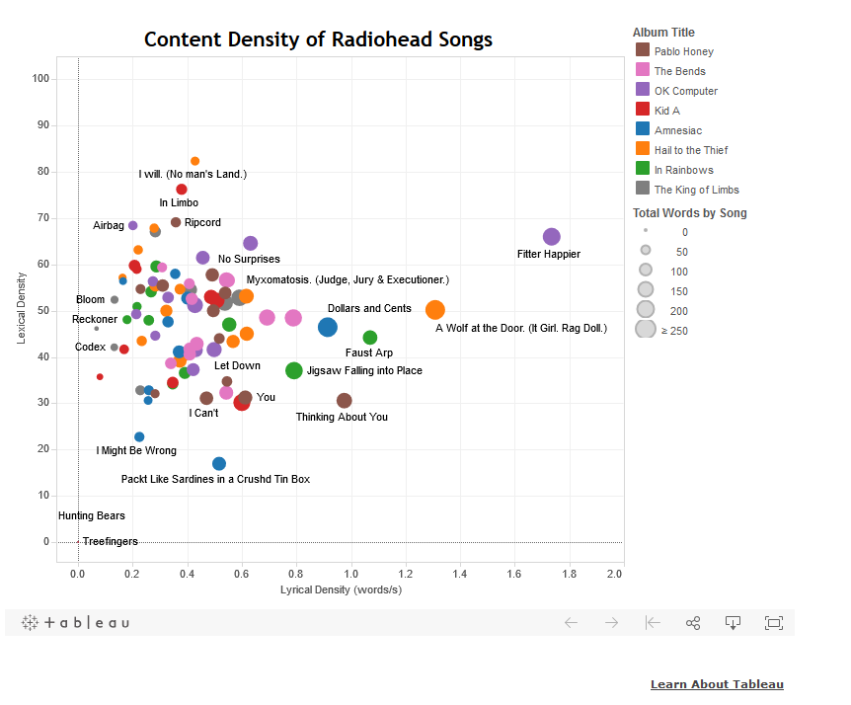

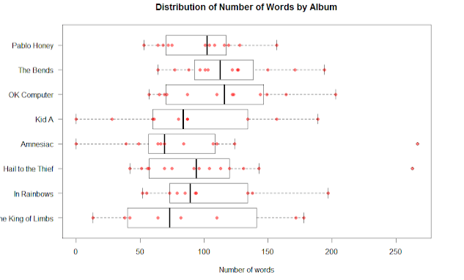

Arc Diagrams

<https://www.r-bloggers.com/arc-diagrams-in-r-les-miserables/>

